Module 1 Lesson 4 Assignment
Chances are you're thinking that worldviews are a lot to think about as we are just beginning Career Life Connections! However, by thinking about your journey from where you have been to where you are right now, you will grow to better understand how you approach the cycle of exploring, planning, reflecting, adapting and deciding when making decisions in your career and life.
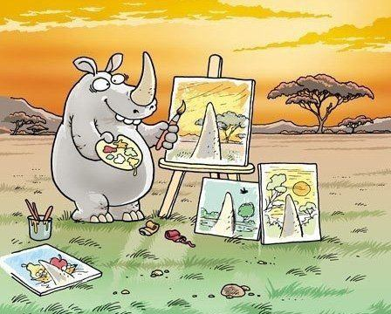
Imagine if we never considered changing our worldview as our experiences and perspectives change!

In a short journal entry (approximately 300-400 words), think about your worldview and how it influences and impacts your values, choices and actions, particularly as it relates to your career-life. This is a really big topic - feel free to use none, some or all of these guiding questions in your response.
- What experiences and knowledge do you think could influence the way a person thinks or behaves?
- How may culture influence our worldview?
- Technology and media has the potential to influence and impact our worldview. Explain how you think access to technology and media influences the opportunities we have.
- Where do our values originate, and how do they impact your career choices?
- How could our worldview impact the goals that we set, following through goals, and celebrating our accomplishments?
- How could varying worldviews impact someone's desire to continue to post-secondary education, or, alternatively, how could attending post-secondary education impact someone's worldview?
- Thinking about your own career and life goals for the next two to three years, describe how your worldview could positively influence your goals.

