Early Middle Ages Notes
- Early Middle Ages
- High Middle Ages
- Late Middle Ages

- Babarian _______________ takes command of Rome in 476.
- Removes the powerless emperor Augustulus
- War all along border of the Roman Empire
“See how swiftly death comes upon the world, and how many people the violence of war has stricken. Some lay as food for dogs; others were killed by the flames that licked their homes. In the villages and country houses, in the fields and in the country side, on every road – death, sorrow, slaughter, fires, and lamentation.”
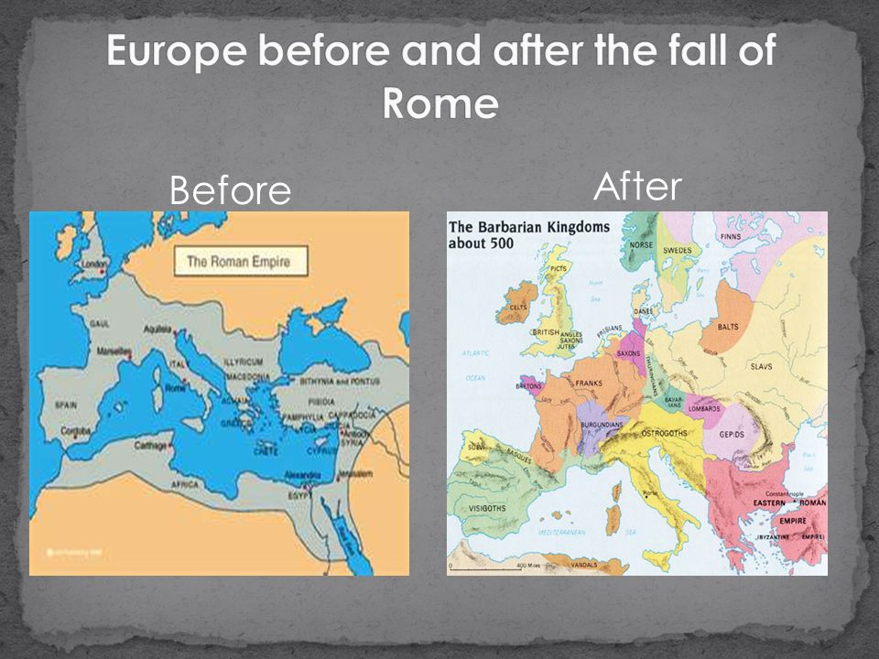

Primer: What are “living standards”?

- As Rome fell to Northern Invaders (410 C.E.), a lawlessness gripped Europe when there was no one to unite the people.
- Rome fell after 600 years of being in power.
- Without the presence of Roman authorities civil structures such as ________
________________________________ began to degrade and fall apart.
- Without laws or an army to enforce them violence became part of everyday life.
- Roads were unsafe to travel and trade between people became strained.
- This part of the middle ages is also called the __________________ because violence, savagery, and death were everywhere.
Vikings
- Vikings sailed and rowed from ____________________ (Norway, Sweden, Denmark) to mainland Europe, Ireland and England.
- Mostly raided villages near the sea.
- Those they did not kill they took as slaves
- ____________________ was their target
The Franks and Charlemagne
- Franks conquer smaller territories and their Kingdom spreads
- The Franks led into Christianity, supported by the church
- Charles Martel aka “Charles the Hammer” takes power, defeats Muslim invaders from Spain
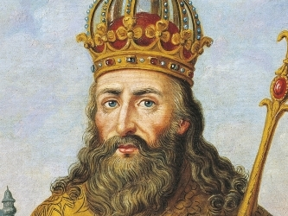
- Charles grandson Charles or “_________________” takes power with support of the Church
- Rules the former Western Roman Empire.
- Ruled for ______ years
- An impressive king.. One of Europe’s most
successful Monarchs
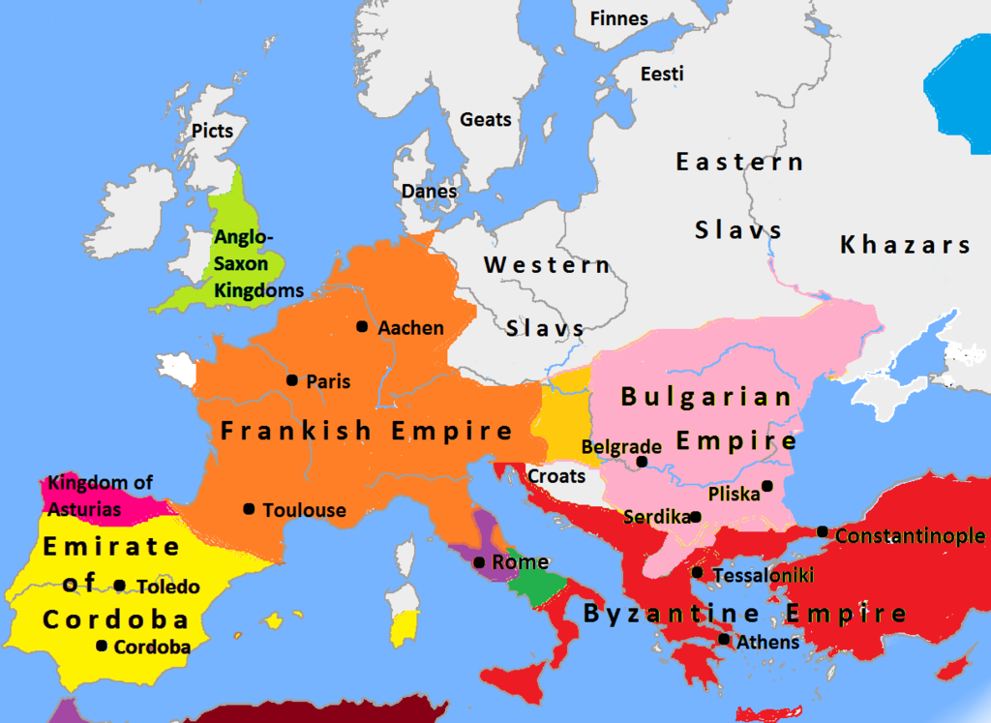

Religion in the Middle Ages
- As life grew difficult people needed hope and inspiration that life was not only about suffering.
- In the middle ages religion blossomed and spread through Europe, Africa, and the middle east.
- This included: _______________________________________
Europe after Charlemagne
- Europe once again becomes divided after Charlemagnes death.
- Made up of smaller kingdoms
- Begins transition into the _____________________.

