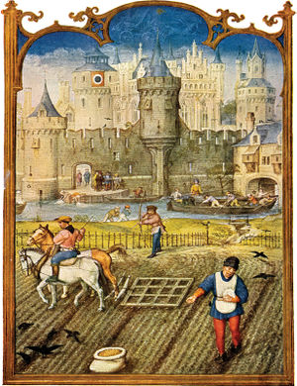
High Middle Ages Notes
- Early Middle Ages
- High Middle Ages
- Late Middle Ages

Middle Ages After Charlemagne
- Without Charlemagne ruling the Franks, the empire fades
- Western Europe once again divided into _________________________
- Viking attacks continue
- People of Europe needed a way to _________________________
Feudalism
- As people tried to develop order in Europe a new form of social hierarchy started to develop: Feudalism
- Feudalism: The _________________________ system that people in the middle ages lived in.
- Feudalism became common around ______________
- Developed based on people’s need for protection/defense
- Under feudalism, land was owned by a king of noble, and was given to vassals in return for their loyalty.
- Power rested in the hands of the landowners. They would give land (a fief) to their vassals, who promised to follow their laws and ______________________
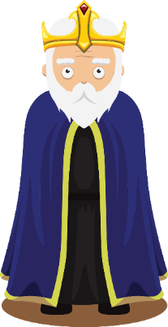
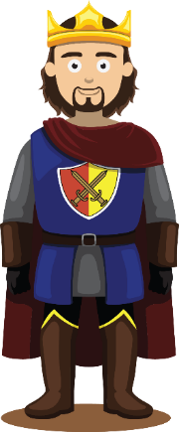
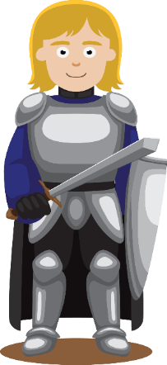
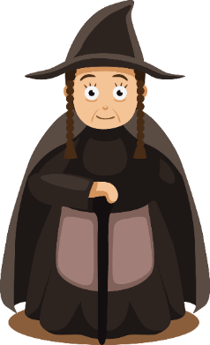
- People received protection in return for service as soldiers or for turning over title and ownership of their land to the larger landowners
- ______________ - An oath of loyalty between knights and lords that stated they would protect the land.
- A knight is a vassal (loyal subject) for his lord and a lord is a vassal for a king

The Pope
- Leader of the Roman Catholic Church
- Popes were seen as God’s representative on earth
The King
- Leader of kingdoms
- Kings gave land to the lords
- All lords/nobles and knights swore an ________________to protect the king’s land
Lords/Nobles
- Swore loyalty to the king. In exchange, nobles were given land called fiefs to protect.
- The Nobles would then obtain knights as vassals of their own
Knights
- ______________ that protected their lord’s land
- They often received “fiefs”(land) for their service
Peasants/Serfs
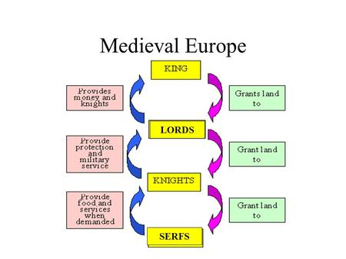
- Worked on the lord’s land (manors) growing and harvesting food for the feudal system
- Received______________ for their service

The Manor
- Feudalism was the way Medieval Europeans organized power/government, the Manor system was how they organized their ________________.
- Manor- a large parcel of land that contained farm land, woodlands, and at least one village.
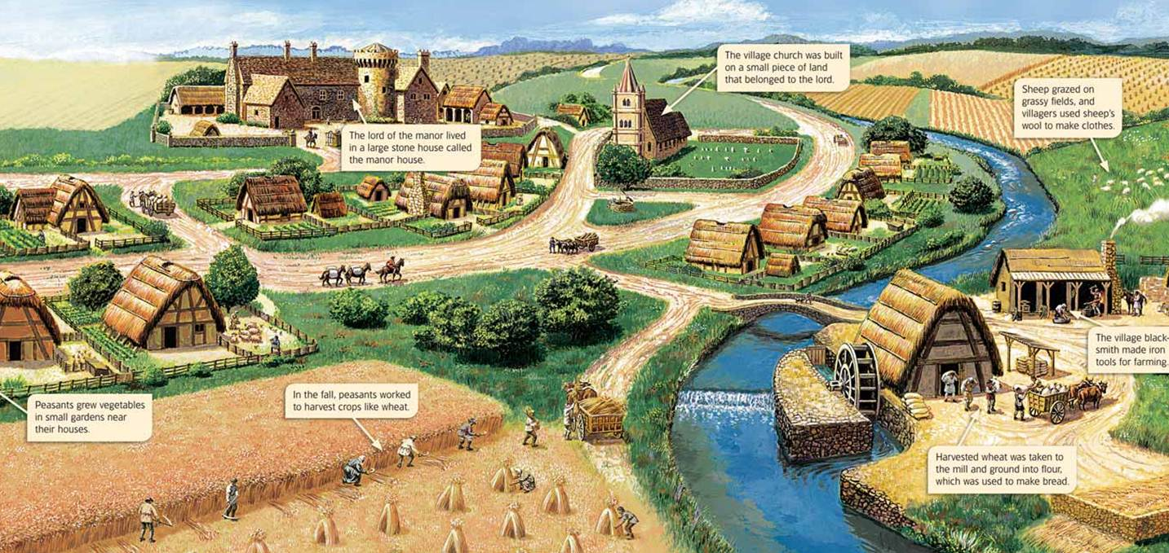
- It also included a large house called the _________________, where the lord/ruler of the manor lived

- Manor villages consisted of: a church, a mill, a blacksmith’s shop. and a tannery.
- A ______________ is where animal skins were turned into leather
Village Life
- The church- very central to village life, almost all village would have had a church
- Priest jobs: marriages, burials, witnessed agreements, and helped those in desperate need.
- Excommunication- when someone is no longer allowed to participate in church. Basically the worst thing that could happen to someone.
- ______________: a tax imposed on villagers equal to one tenth of a persons income in cash or crops.

