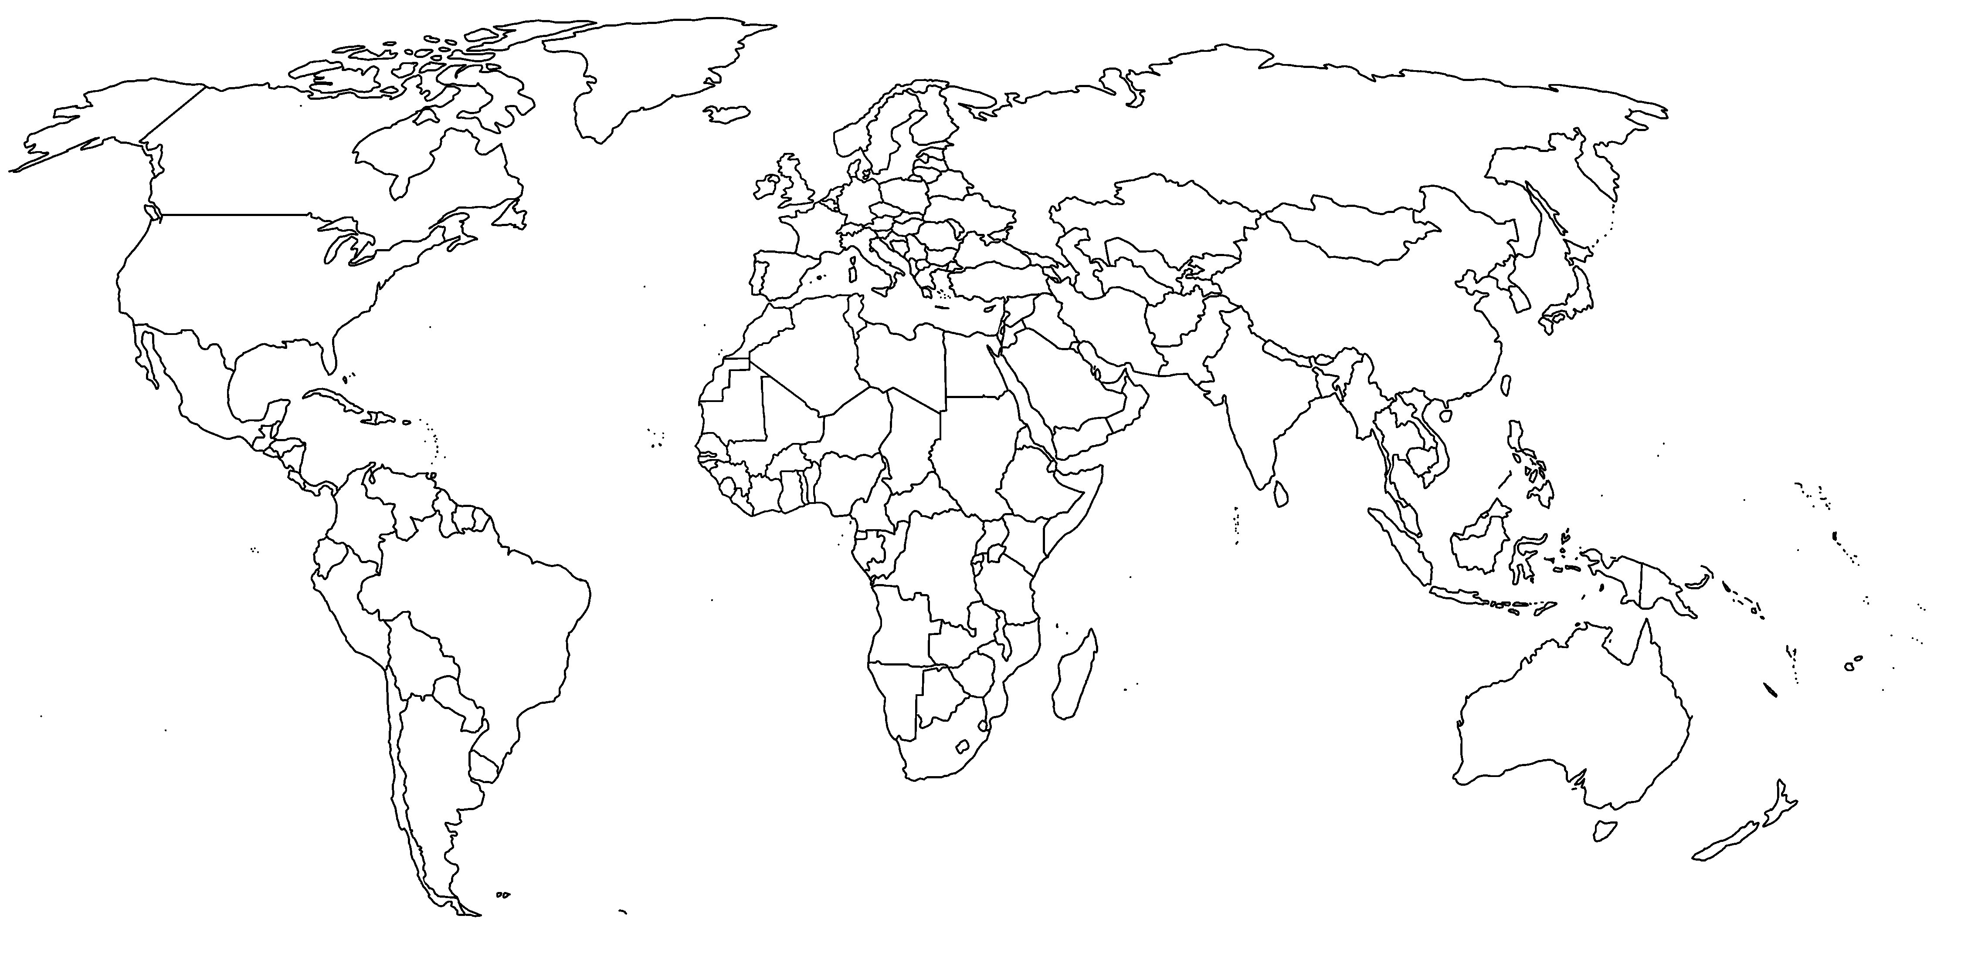
National Geographic Plastic Map Activity
https://www.nationalgeographic.com/magazine/2018/06/the-journey-of-plastic-around-the-globe/

- Using the map on the first page, mark/label Henderson Island.
- How many pieces of debris can be found on Henderson Island?

- Why do you think so much debris collects on Henderson Island?

- What is “mismanaged plastic waste”?

- Which regions in the world have the most mismanaged plastic waste? Which have the least?

- What factors do you think would cause some regions to have more/less mismanaged plastic waste than others?

- How can plastic on the land make its way to the ocean?

- On your map, label 5 of the regions that have the most plastic waste entering the ocean from rivers per year. You can create a symbol to use to label these regions, but make sure you have a legend on your map where this is explained.

- Why do North America and Europe have less plastic waste that reaches the ocean?

- Which river in the world brings the most plastic to the ocean? Label / draw it on your map
- Draw/label 4 other rivers on your map that are among the top contributors to ocean plastic levels.

- How much of the total plastic waste entering the ocean do the 20 most polluted rivers account for?

- How does plastic move around once it reaches the ocean?

- How many species have been affected by ocean plastics?

