The Crusades Map Assignment
Use the map packet or the maps found at to complete the following assignment.
Make a Map!
Follow the directions below to complete the map on the next page. You will want to save this map as we will use it again later.
- Label in light blue the Mediterranean Sea and the English Channel.

- Put a dot at and label in black the cities of Paris, London, Rome, Venice, Marseille, Constantinople, and Antioch.

- In brown, label the islands of Crete, Cyprus, Corsica, and Sardinia.

- In dark green, label the Christian kingdoms of England, France, Sicily, Scotland, Castile, Argon, Portugal, and the Holy Roman and Byzantine Empires.

- Lightly shade all Christian lands in green.

- Lightly shade all Muslim lands in purple.

- Put a blue star at and label the city of Jerusalem.

- Use red to make a symbol that represents a battle and put it at and label the city of Acre.

- Draw and label the paths taken by King Richard the Lionhearted and King Phillip Augustus to Acre.

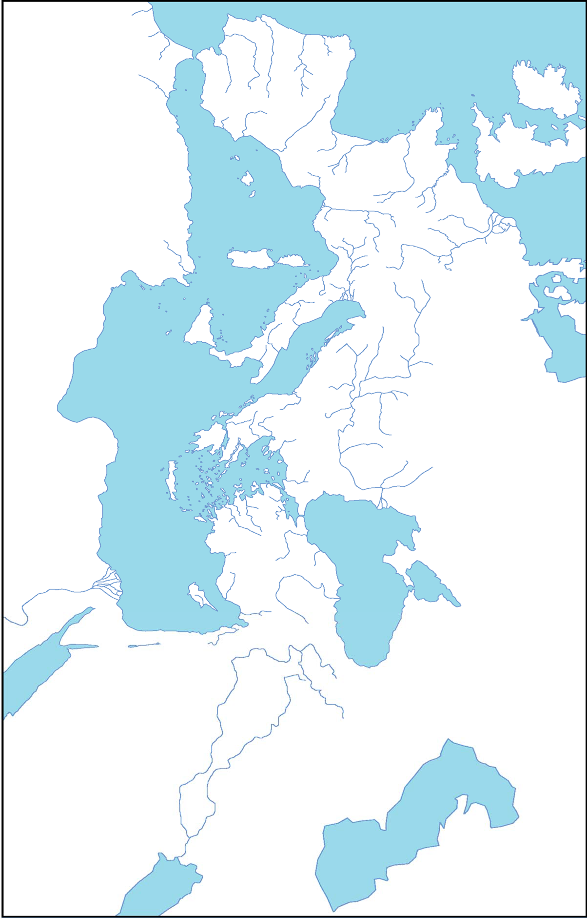

Interpreting the Maps!

Use the maps provided online, and your information package to answer the questions below.
- The men (and they were almost all men) who answered the Pope’s call to take back the Holy Land were called Crusaders. From which parts of Europe did most of these Crusaders come from?
________________________________________________________________________________________________________________________________________________________________________________________________________________________________________________________________________________.
- What was the main goal of the Crusades?
________________________________________________________________________________________________________________________________________________________________________________________________________________________________________________________________________________
- Why do you think the Pope called the first crusade a “just” or “honorable” war?

________________________________________________________________________________________________________________________________________________________________________________________________________________________________________________________________________________

- Which city appears to be the focus of the Crusaders’ efforts? Which Crusade did not make it there?
_______________________________________________________________________________________________________________________________________________________________________________________________________________

- How many years separated the First and the Fourth Crusades?
_____________________________________________________________________________________________

- Which Crusade was the most successful? How do you know?
____________________________________________________________________________________________________________________________________________________________________________________________________________________________________________________________________________________

- The area around the Jerusalem is often called the Holy Land. Who controlled the Holy Land at the time of the Third Crusade? Were those people Christian or Muslim?
__________________________________________________________________________________________________________________________________________
__________________________________________________________________________________________________________________________________________

- Looking at the information from the maps, does it look like the Crusades were a pilgrimage (a journey to a holy or sacred place) or a holy war (a war fought by believers of a religion to spread or defend their religion)? Give me your opinion supported by your reasons, as well as facts from the maps and info package.
__________________________________________________________________________________________________________________________________________
__________________________________________________________________________________________________________________________________________
__________________________________________________________________________________________________________________________________________
__________________________________________________________________________________________________________________________________________

